**ALX AICE: Milestone #6 Worksheet**

| **Simulation Recap** |
| --- |
| This week, your manager at Waga tasked you to complete your online professional toolkit and send in your portfolio website. This Milestone worksheet helps you collate all the activities you carried out in one place. Please follow the steps and instructions to complete the milestone successfully.  **Tip:** [**Check out the rubric**](https://docs.google.com/document/d/1tT1fiVRLug3RhfPhVxe7j_r-wPondbLdRWOrAULp3vQ/copy) **before submitting your Milestone Worksheet.** |

**Step 1: Your Cover Letter**

**Locate your cover letter PDF from your cover letter activity.**

Then, paste the link to the pdf of your cover letter in the box below, and make sure anyone can view the link you are pasting.

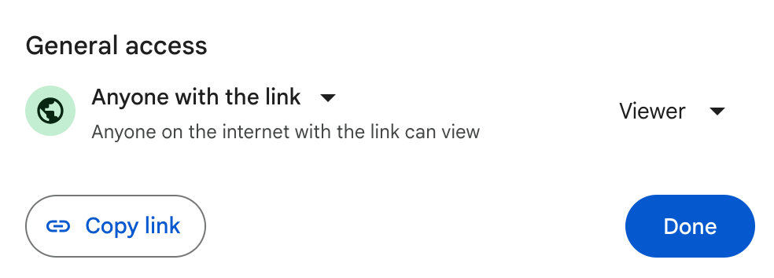

**Step 1: My Cover Letter**

| [coverletter_Habtamu_wolde.pdf](https://drive.google.com/file/d/1jYk-gsv_MoPOb3Ee8s6zAhAquDSvjPYV/view?usp=sharing) |
| --- |

**Step 2: Your Portfolio Website**

**Please paste the link to your portfolio website in the box below. At a minimum, your website must contain:**

* Your contact information (Your name, a tagline briefly stating your professional identity)
* Your Bio
* Your Portfolio/Sample Work **(This can be your VacAI presentation or video if you don’t have any sample work for now)**

**Step 2: Link to my portfolio Website**

| <https://habtamu-firstportfolio-website.framer.ai/page-4> |
| --- |

**Step 3: Mapped Network**

**Please paste the link to your updated** [**AiCE Target Industry Workbook**](https://docs.google.com/spreadsheets/d/1vS_u7IJSr8tOzHHH5f8Bs6-gT5GJlEtcrEySDzZJOSE/copy)

Make sure you have mapped at least 7 of your contacts in the **Mapping My Network tab**.

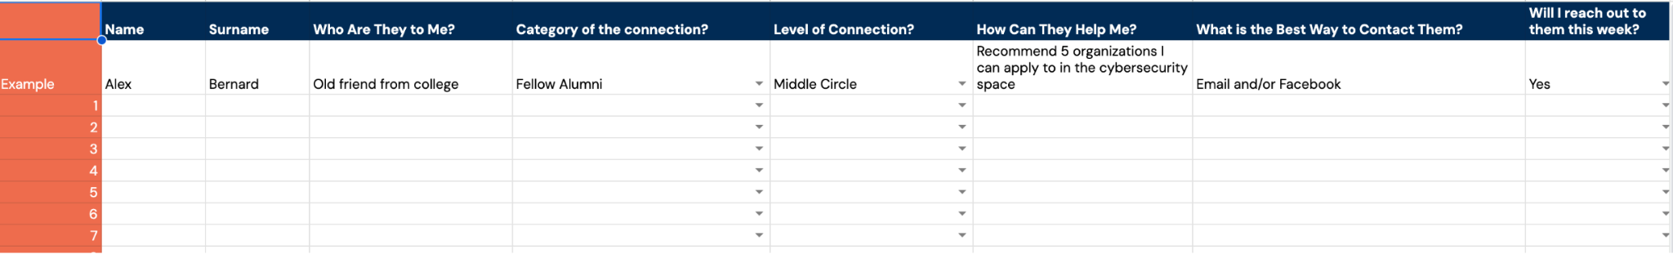

**Step 3: Link to Mapped Network**

| [AiCE Target Industry Workbook](https://docs.google.com/spreadsheets/d/1II310Jt5Y5eL9GHS2u8eMBc076C6cSxU5LSuHheZnUg/edit?usp=sharing) |
| --- |

**Step 4: Skills Map Update**

**Please paste the link to your updated** [**skills map**](https://docs.google.com/spreadsheets/d/1_N42QcmTeCikG3NiCePnsQFLTE8p8FU-lyAZ18Hnpog/copy)**, and make sure you have updated your ratings in the row End of AICE sections ONLY [columns C and G].**

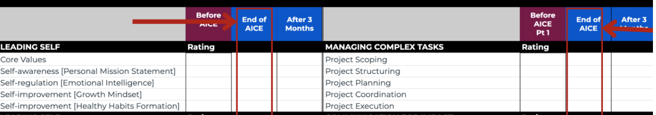

**Step 4: Link to Skills Map Update**

| [AICE Skills Tracker_Habtamu_Wolde](https://docs.google.com/spreadsheets/d/1K3ZNov2SZx7PwdaOc_ng7hnKBx5AeQXeyYJ0wkjjFo8/edit?usp=sharing) |
| --- |

**Step 5: AI Toolkit**

**To access your AI Toolkit, Go to your personal ALX AICE Google Drive, then locate your updated** [**AI Toolkit Spreadsheet.**](https://docs.google.com/spreadsheets/d/11HJQIo3FncvMSBTs4fZ413aPBSmLrhXnfoXx5dqoeqA/copy)

Click **"Share"** (under the 3 dots) and adjust the settings so that it looks like this:



# **Then, copy the link and paste it in the box below;**

**Step 5: Link AI Toolkit**

| [AICE AI ToolKit_Habtamu_Wolde](https://docs.google.com/spreadsheets/d/1_lzTTNa11FUXXYNQqW-rTbZUhrh-9mqUyAPHh2iEo50/edit?usp=sharing) |
| --- |

*If you need more help with this, Google for video instructions on sharing files in Google Drive, or ask a peer.*

**Step 6: Reflection on the use of AI**

Take a moment to reflect on how you used AI this week, you are to write a short paragraph answering the following reflection questions:

**Reflection on the use of AI**

| 1. *What are 3 ways you plan to use professionally moving forward?* 2. *Which AI tools will you plan to continue using after this course?* 3. *Consider the implications of AI on employment and the workforce. How might AI shape job roles and industries in the coming years?* 4. *Imagine a future where AI is even more advanced and integrated into society. What potential opportunities and concerns do you envision?* 5. *What have you been most excited about when it comes to AI in this course?* 6. *What is one thing you wish this course addressed or included with regard to AI?* |
| --- |

**Step 6: My Reflection Response**

| Moving forward professionally, I plan to leverage AI in three key ways.  **Firstly**, I intend to integrate AI-powered tools such as **ChatGPT**, **Todoist**, and **JuliusAI** into my workflow to boost productivity, streamline communication, and enhance data visualization and analysis.  **Secondly**, I aim to continue expanding my AI skill set through continuous learning, staying updated on the latest advancements and exploring new tools and techniques to stay ahead in my field.  **Lastly**, I will incorporate AI into problem-solving and decision-making processes, utilizing AI solutions to drive innovation and efficiency in strategic planning and data-driven decision-making.  Among the AI tools I plan to continue using after this course are **ChatGPT** for generating creative ideas and automating tasks, **Todoist** for efficient task management, and **JuliusAI** for data visualization and analysis. Additionally, I'll continue utilizing writing enhancement tools like **Grammarly**, **Quillbot**, **HemingwayApp**, and **Sudowrite** to improve writing quality and efficiency.  In a future where AI is more advanced and integrated into society, I envision opportunities for AI-driven innovations to revolutionize industries such as **healthcare**, **transportation**, and **education**, leading to improved efficiency, accessibility, and quality of services.  Throughout this course, I've been most excited about exploring the diverse range of AI tools and applications, from natural language processing and task management to data visualization and prototyping. The depth and breadth of AI technologies showcased have been incredibly fascinating and empowering.  One aspect I wish this course addressed more thoroughly is the ethical implications of AI. Delving deeper into discussions on bias, fairness, transparency, and accountability in AI algorithms and decision-making processes would provide a more comprehensive understanding of the ethical considerations surrounding AI development and deployment. |
| --- |